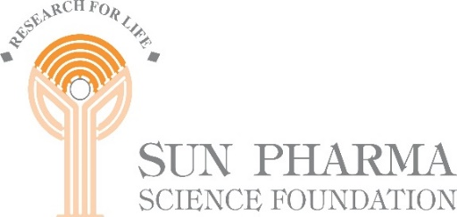

**Sun Pharma Science Foundation National Symposium on**

“**PATHOGEN DISCOVERY AND MANAGEMENT OF FUTURE EPIDEMICS**”

**In collaboration with**

**INSTITUTE OF LIFE SCIENCES, BHUBANESWAR**

**Date : February 09, 2023, 2023 – 09:30 to 18:00 hours**

**Venue : ILS Auditorium, Chandrasekharpur, Bhubaneswar.**

We are just emerging from a global pandemic. The first question we ask ourselves, is how do we ensure that humanity does not go through this again? Can we ensure this? How can we be prepared for pandemics? If so, what role does science play here?

We live in the Anthropocene, an era dominated by humans. Changing landscapes, and the associated changes in species, communities and their distributions can lead to zoonotic spillover. Understanding the ecological and evolutionary drivers for spillover, and building predictive models to understand spillover dynamics is clearly important. At the same time, continued surveillance to understand changes in trends of re-emerging zoonoses is critical. Finally, response to outbreaks, through epidemiological studies and vaccine development is critical. In summary, pandemic preparedness requires a suite of disciplines, interdisciplinary skills and quantitative frameworks. Unfortunately, such integrative approaches are relatively rare in India, especially with regards to ecology and evolution.

We are organizing a day-long symposium that brings talks that focus on three themes: ecology and evolution, surveillance and outbreak investigation and response. We would wrap up the day with a panel discussion, and opportunities for participants to ask questions and discuss their thoughts.

**For Details:** [**https://sunpharmasciencefoundation.net**/](https://sunpharmasciencefoundation.net/)

**For Registration :** [**https://www.ils.res.in/pathogen-discovery/**](https://ind01.safelinks.protection.outlook.com/?url=https%3A%2F%2Fwww.ils.res.in%2Fpathogen-discovery%2F&data=05%7C02%7CThangachan.Anthappan%40sunpharma.com%7C8df652a565ea4c115efe08dc119109ff%7C8f20da68dda24932bb0f800d8579885d%7C0%7C0%7C638404561837566534%7CUnknown%7CTWFpbGZsb3d8eyJWIjoiMC4wLjAwMDAiLCJQIjoiV2luMzIiLCJBTiI6Ik1haWwiLCJXVCI6Mn0%3D%7C3000%7C%7C%7C&sdata=MkrJIQjIFwCC5vxxLbnyi2i3CcFjca1WTaeUmY4rShg%3D&reserved=0)

**Scientific Advisory Committee:**

Prof. Virander S. Chauhan, Chairman SPSF

Dr. B. Ravindran, DBT-ILS

Dr. Uma Ramakrishnan, NCBS

Dr. Rajeeb K. Swain, DBT-ILS

Dr. Mamoni Dash, DBT-ILS

Dr. Amit Nasa, Member Secretory, SPSF

For further information, please contact:-

The Office of Sun Pharma Science Foundation

8c, 8th Floor, Hansalaya Building, 15, Barakhamba Road,

New Delhi : 110 001, India. Tel : (91-11)23721414/ 1415

Email:[sunpharma.sciencefoundation@sunpharma.com](mailto:sunpharma.sciencefoundation@sunpharma.com); Website : https://sunpharmasciencefoundation.net/